<https://www.upgrad.com/blog/python-gui-projects-project-ideas-for-beginners/>

<https://www.pythonistaplanet.com/python-tkinter-project-ideas/>

1. Age calculator >> date time module backend logic  
    Frontend single button with image and 4 inputs name , year, month and day
2. <https://www.youtube.com/watch?v=D2SkCdNZW08#action=share>
3. 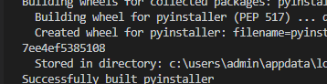

<https://linuxconfig.org/bash-scripting-tutorial-for-beginners>

<https://www.shellscript.sh/>